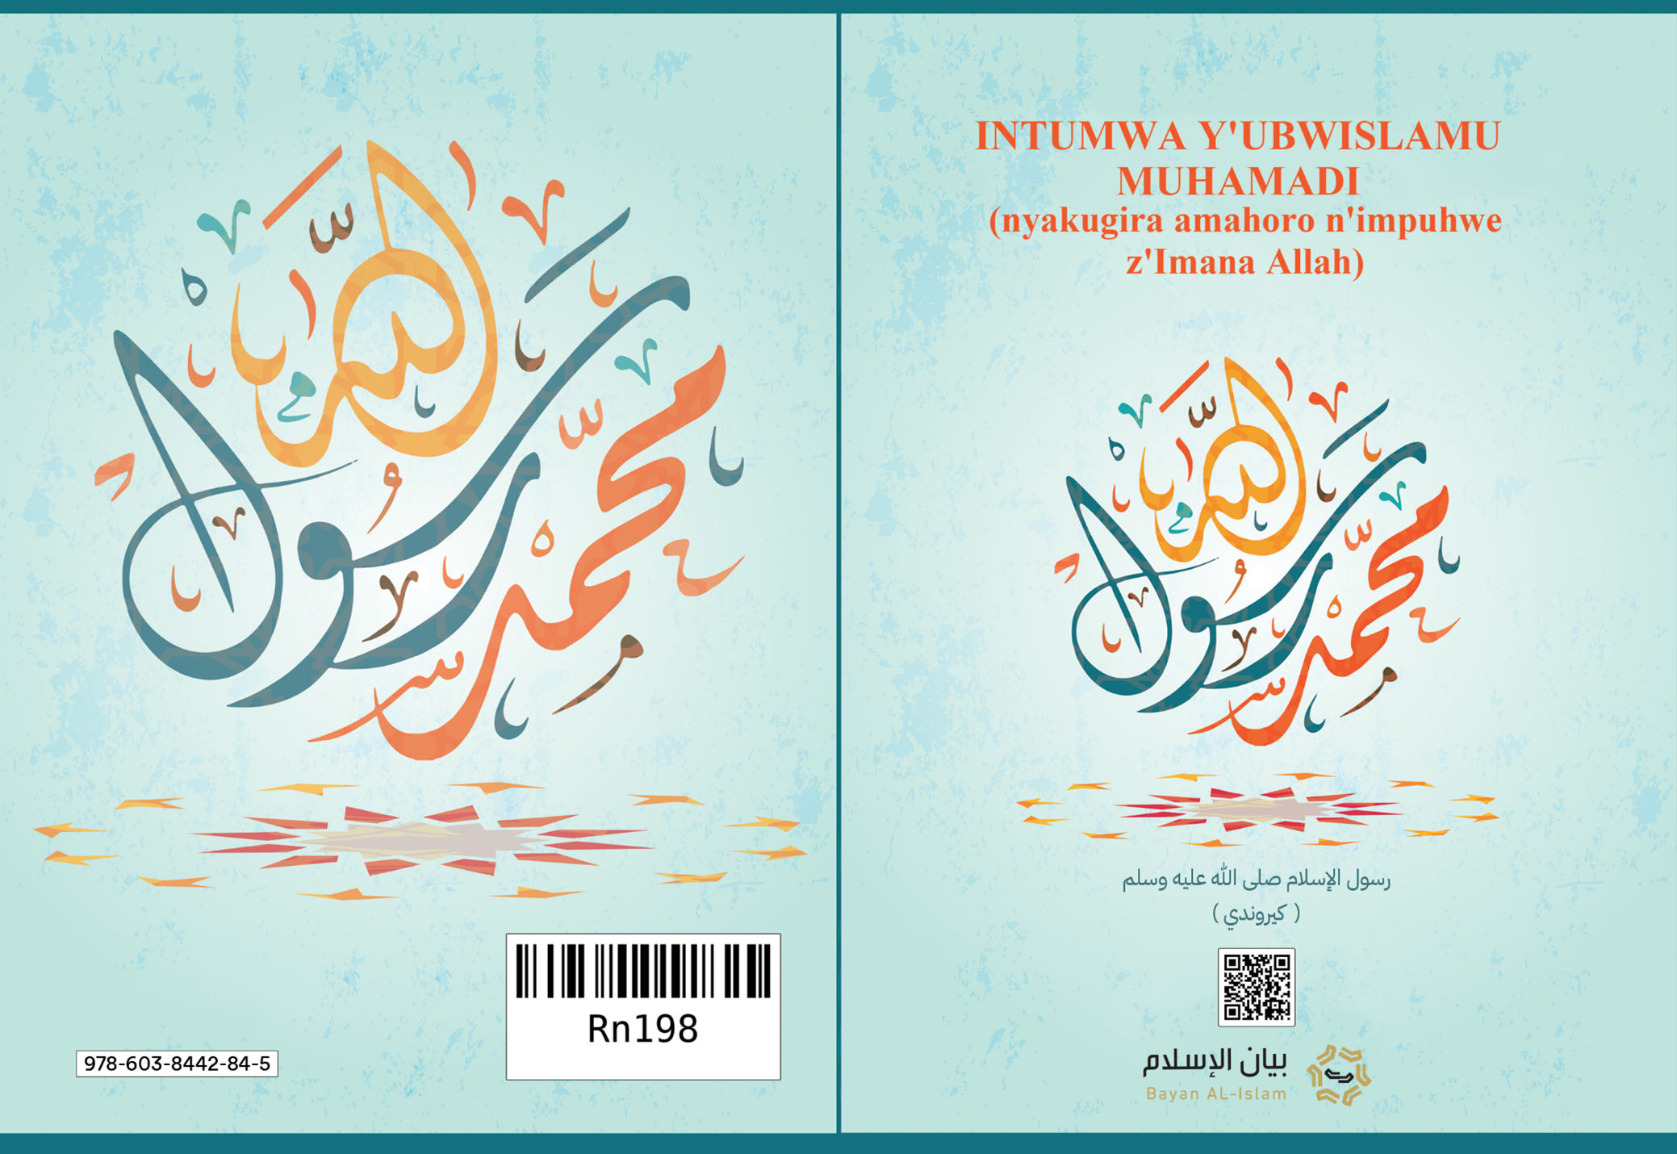
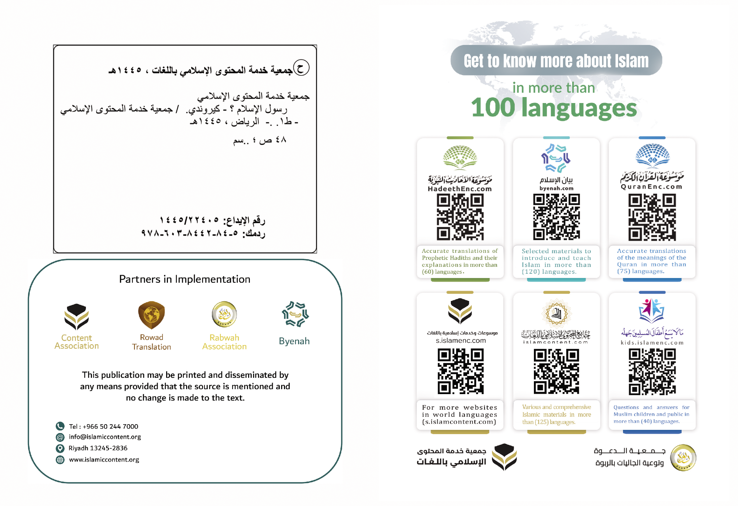


INTUMWA Y'UBWISLAMU MUHAMADI


(nyakugira amahoro n'impuhwe z'Imana Allah)

Kw'izina ry'Imana Allah, Nyenimpuhwe ku biremwa, Nyenimbabazi ku batoni bayo

INTUMWA Y'UBWISLAMU MUHAMADI (nyakugira amahoro n'impuhwe z'Imana Allah)
Iyi, ni incamake ku bijanye n'Intumwa y'ubwislamu Muhamadi (nyakugira amahoro n'impuhwe z'Imana Allah), aho nerekanamwo izina ryiwe, inkomoko yiwe, igihugu yavukiyemwo, ukuntu yarongoye, ubutumwa bwiwe, ico yaje kurarikira, ibitangaro vyerekana ivugishwamana ryiwe, hamwe rero n'inyifato y'abamurwanya (ukuntu bigenjeje kuri we).

*****

1. IZINA, INKOMOKO N'IGIHUGU YAVUKIYEMWO AKANAKURIRAMWO
Intumwa y'ubwislamu, ni Muhamadi mwene Abdi Llaahi, Abdi Llaahi mwene Abdu l-Muttwalib, Abdu l-Muttwalib mwene Haashimu, uyu Haashimu na we akaba akomoka mu ruvyaro rwa Ismayili mwene Ibrahimu (ba nyakugira amahoro y'Imana Allah).
Ikomoka ryiwe kuri Ibrahimu rero, ni uko Umuvugishwamana Ibrahimu (nyakugira amahoro y'Imana Allah) yavuye muri Shaamu agana i Makka, akaba yari kumwe n'umukenyezi wiwe Haajara hamwe n'umwana wiwe Ismayili akiri uruyoya; araheza abacumbikira i Makka ku kwubahiriza itegeko yahawe n'Imana Allah. Ismayili amaze kugera mu bigero akaba umusore, Umuvugishwamana Ibrahimu (nyakugira amahoro y'Imana Allah), yaragarutse i Makka, araheza yubaka Al-Ka'ba ari kumwe n'umuhungu wiwe Ismayili (ba nyakugira amahoro y'Imana Allah), maze abantu baragwirirana mu micungararo ya Al-Ka'ba, Makka ica iba ihurumbiro ry'abaza kwitonesha ku Mana Allah, Umubungabunzi w'ibiremwa vyose, bakaza baje gushengerera ingoro yayo ntagatifu. Abantu rero, barashishikaye kwiyegereza Imana Allah mu bikorwa vyabo vyose banayisenga ari Imwe Rudende ata kuyibangikanya mu kiringo c'ibinjana n'ibindi, bisunze ukwemera-ndemanwa kwa Ibrahimu (nyakugira amahoro y'Imana Allah).
Mu nyuma y'aho rero, ni ho haba uguhusha inzira y'ukwemera Imana Imwe Rudende Allah, gutyo ikigobe c'Abarabu gicika nk'ibindi bihugu vyo kw'isi mu kwibonekezamwo ibigirwamana n'imigenzo ijana na vyo: nko gusenga ibishusho (ibibazano), uguhamba abana b'abakobwa babona (ari bazima), ukurenganya abakenyezi, ukubesha, ukunywa inzoga, ugukora ivyaha vy'agahomerabunwa, ukwihagira mu kurya amatungo y'impfuvyi, hamwe rero n'ukurya inyungu izira (riba), n'ibindi. Muri ukwo kuntu abantu bari babayeho i Makka, ni ho havuka Intumwa y'ubwislamu Muhamadi mwene Abdi Llaahi, akomoka mu ruvyaro rwa Ismayili mwene Ibrahimu (ba nyakugira amahoro y'Imana Allah), hari mu mwaka w'amajana atanu na mirongo indwi na rimwe (571) kuva Intumwa Isa ivutse. Se wa Muhamadi (nyakugira amahoro n'impuhwe z'Imana Allah), yapfuye imbere y'ivuka ryiwe; nyina na we apfa mu nyuma y'ivuka ryiwe haciye imyaka itandatu, araheza arerwa na sewabo Abu Twaalibu, gutyo akura ari impfuvyi, akenye ukuraho, abeshejweho no guca ingero.
*****

2. UKWABIRANA N'UMUPFASONI YAHEZAGIWE
Intumwa Muhamadi (nyakugira amahoro n'impuhwe z'Imana Allah), imaze gukwiza imyaka mirongo ibiri n'itanu, yahavuye irongora umupfasoni mu bakenyezi b'i Makka, uwo na we akaba ari Khadija umukobwa wa Khuwaylidi (Imana Allah Imwishimire), maze iraheza imuvyarako abana b'abakobwa bane n'abahungu babiri; abahungu bakaba bapfuye bakiri bato. Yabanye n'umuryango wayo mu mpuhwe no mu rukundo nta ngere, ari na co gituma umukenyezi Khadija yakunda cane umugabo wiwe; ni nk'uko nyene n'umugabo yakunda cane umukenyezi wiwe, kandi ntiyigeze yibagira namba urukundo yakunda umukenyezi wiwe n'inyuma y'aho apfiriye imyaka n'iyindi; yahora abaga n'intungwa akayigaburira abagenzi ba Khadija (Imana Allah Imwishimire), mu ntumbero yo kubaha iteka n'icubahiro; ivyo bikaba vyamwibutsa ubugwaneza n'urukundo yakunda Khadidja.
*****

3. INTANGO Y'IHISHURIRWA
Intumwa Muhamadi (nyakugira amahoro n'impuhwe z'Imana Allah), yama na ntaryo irangwa n'ingeso nziza kuva ikiremwa n'Imana Allah; abantu yabanye na bo, bose bayita Mvugakuri-Mwizigirwa (imvugakuri y'umwizigirwa), yarifadikanya na bo mu bikorwa bihambaye, ikanka ikankiriza ibikorwa vy'ibangikanyamana, maze ntiyifadikanye n'ababangikanyamana mu bikorwa vyabo. Muhamadi amaze rero gushikana imyaka mirongo ine y'amavuko ari i Makka, Imana Allah Yaramuhisemwo kugira abe Intumwa, maze umumalayika Jibrili (nyakugira amahoro y'Imana Allah) araza amuhishurira Aayah z'intango z'igisomwa co mu Gitabu gitagatifu Qor'ani, na yo ikaba ari amajambo y'Imana Allah, avuga uku:
﴿ٱقۡرَأۡ بِٱسۡمِ رَبِّكَ ٱلَّذِي خَلَقَ. خَلَقَ ٱلۡإِنسَٰنَ مِنۡ عَلَقٍ. ٱقۡرَأۡ وَرَبُّكَ ٱلۡأَكۡرَمُ. ٱلَّذِي عَلَّمَ بِٱلۡقَلَمِ. عَلَّمَ ٱلۡإِنسَٰنَ مَا لَمۡ يَعۡلَمۡ﴾ [العلق: 1-5].
﴾Muvugishwamana! Soma ivyo wahishuriwe muri Qor’ani, maze utangure kw’izina ry’Imana yawe Allah Yaremye; Yaremye zina kiremwa-muntu mu maraso avuze. Muvugishwamana! Soma ivyo wahishuriwe muri Qor’ani, wizeye ko Imana yawe Rurema Allah ari Yo Mugiraneza-ntangere; Yigishije ibiremwa kwandika n’ikaramu; Yigishije kiremwa-muntu ivyo kitari kizi, Iraheza Igikura mu muzimagiza w’ubujuju Igishira mu muco w’ubumenyi ﴿ (Al'Alaq: 1-5).
Yahavuye rero aza ku mukenyezi wiwe Khadija (Imana Allah Imwishimire) adegedwa, umutima usimbagurika, araheza aramwiganira ivyamushikiye, Khadija na we aca aramuhumuriza (aramutururuza), amujana kwa mwene sewabo, uyo mwene sewabo yitwa Waraqa mwene Nawfali (yari umunaswara yasomye Tawurati n'Injili), maze Khadidja aca amubwira ati: "Ewe mwene datawacu! Tega amatwi wumvirize ivyo umuhungwanyu
akubwira", maze Waraqa na we aca avuga ati: "Ewe muhungwanje! Ni ibiki wabonye?". Intumwa y'Imana (nyakugira amahoro n'impuhwe z'Imana Allah), ica imugira ku muriri, iramwiganira ido n'ido inkuru y'ivyo yabonye. Waraqa araheza ayibwira ati:"Uwo wabonye, ni umumalayika yahora arungikwa n'Imana Allah kwa Musa, ese ico gihe noba nkiritera nkarisama, ese ico gihe noba nkiriho wirukanwe (ukomorwa) n'abantu bawe!". Maze Intumwa (nyakugira amahoro n'impuhwe z'Imana Allah), ica imubaza iti: "Aho nyene uvuga ko bazonyirukana (bazonyomora)!"; na we aca ayishura ati: "Cane nyene! Nta mugabo n'umwe yigeze arungikwa yibangikanije nk'ivyo warungikanwe, kiretse ko yarwanywa n'abo yarungitsweko; mu gihe rero noba nkiriho, umusi wirukanwe (womowe), nzokurwanako ukuri kwo kukurwanako (nzogutabara nya kugutabara)".
Intumwa Muhamadi (nyakugira amahoro n'impuhwe z'Imana Allah), ikiri i Makka, yabandanije ihishurirwa Qor'ani n'Imana Allah, maze ikururukirwa na Jibrili avuye ku Mana Rurema Allah, Umubungabunzi w'ibiremwa vyose, ayizaniye ido n'ido y'ibijanye n'ubutumwa. Intumwa Muhamadi (nyakugira amahoro n'impuhwe z'Imana Allah), yarashishikaye rero kurarikira abantu bayo yarungitsweko ko bokurikira ubwislamu, maze na bo barayiyamiriza baranayirwanya, baraheza bayisaba ko yovavanura n'ubutumwa bwayo, bagaheza bakayironsa amatungo n'ubwami. Ivyo vyose yaravyanse, baca bayibwira nk'uko abo hambere yayo babwiwe, abaserukira abandi mu bagarariji, babwiye Intumwa barungikiwe, ko iroga, irementanya ikaba n'umubeshi, barayibangamira ku buryo ibura umwidegemvyo, bakayikubita, bagacura bufuni na buhoro n'abayikurikiye bose. Hamwe n'ivyo vyose, Intumwa Muhamadi (nyakugira amahoro n'impuhwe z'Imana Allah), yashishikaye irarikira abantu b'i Makka, kwemera Imana Imwe Rudende Allah, igatumbera na canecane ahahurira abantu benshi mu bihe vy'ishengerera ry'ingoro ntagatifu, no mu bihe vy'irema ry'isoko rusangi rihuza Abarabu bose, igaheza rero ikabonana n'abantu muri ivyo bihe, ibararikira ubwislamu. Ntiyigeze ibakundisha ubwislamu mu kubaha ibihendamaso vy'isi canke ubutegetsi, ntiyigeze ibahatira ku bwislamu ikoresheje umupanga, kira noneho nta n'ubutegetsi yari ifise, eka ntiyari n'umwami. Ikiri mu ntango yo kurarikira abantu ubwislamu, yarahize n'abatayemera ko bozana ibisa n'ivyo yabazaniye muri Qor'ani ntagatifu, birabata ku w'amazi. Ni uko rero, yashishikaye ihiga n'abayirwanya, gushika n'aho hemera bamwe mu ngendanyi zayo (Imana Allah Izishimire zose).
Ikiri aho nyene i Makka, Intumwa Muhamadi (nyakugira amahoro n'impuhwe z'Imana Allah), Imana Allah Yarayiteye iteka mu kuyikorera igitangaro gihambaye, ico na co si ikindi, ni igitangaro c'urugendo rw'ijoro (israa-i) ruyikura i Makka rukayishikana kuri Baytu l-Maqds (muri Palestina), rwakurikiwe n'iduzwa ryayo mw'ijuru (mi'raaji). Ikindi kizwi, ni uko kandi Imana Allah Yadugije mw'ijuru, Umuvugishwamana Ilyaasi na Masiihi mwene Mariyamu (ba nyakugira amahoro y'Imana Allah); nk'uko bivugwa n'abislamu hamwe n'abanaswara. Umuvugishwamana Muhamadi (nyakugira amahoro n'impuhwe z'Imana Allah) rero muri iryo duzwa ryo mw'ijuru, yarahawe n'Imana Allah ibwirizwa ryo gusenga, rikaba ari ryo sengesho abislamu basenga gatanu ku musi. Mu gisagara ca Makka, na ho nyene harabereye ikindi gitangaro gihambaye, na co kikaba ari isaduka ry'ukwezi, abantu biboneye n'amaso ukuri kwamye.
Abagarariji b'Abakurayishi b'i Makka rero, barakoresheje uburyo bwose bashoboye kugira bayibere intambamyi, bakoresha urwenge kugira bayankishe abantu, bayigenzako mu kwama basavye ko yobereka ibitangaro; baranafadikanije n'abayahudi kugira babaronse ivyemezo vyobafasha mu kuyihaririza no mu kuyibera intambamyi ngo ntiyumvirwe n'abantu.
Igihe rero abagarariji b'Abakurayishi b'i Makka bashishikariye gucinyiza ata guhesha abemeramana, Umuvugishwamana Muhamadi (nyakugira amahoro n'impuhwe z'Imana Allah) yahavuye arekurira abemeramana kwimukira muri Habasha (Etiyopiya y'ubu); maze ababwira ati: "Mu vy'ukuri, aho Habasha mwumva, hatwara umwami w'intungane, ku buryo ata muntu n'umwe arenganywa ageze iwe". Uwo mwami rero akaba yari umunaswara. Ico gihe rero mu bemeramana, himutse imigwi ibiri ija muri Habasha. Nya migwi imaze kugerayo, yarasiguriye umwami yahatwara, akaba yitwa Al-Najaashiy, idini ryigishijwe n'Umuvugishwamana Muhamadi (nyakugira amahoro n'impuhwe z'Imana Allah), nya mwami aca arinjira mu bwislamu, maze aca avuga ati: "Ndarahiye kw'izina ry'Imana Allah! Ko iri dini koko rikomoka kuri ca gishirira nyene idini rya Musa (nyakugira amahoro y'Imana Allah) ryakomokako".
Abo bimukira, ni bamwe mu bari baramwemeye mu mugwi w'abari baje bavuye muri Madina, maze bamwemerera ko babaye abislamu n'uko bazomutabara niyaramuka yimukiye i Madina (ico gihe hitwa Yathribu); muri bo rero, abari babaye baragumye i Makka, Umuvugishwamana Muhamadi (nyakugira amahoro n'impuhwe z'Imana Allah) yahavuye abarekurira kwimukira i Madina, baraheza barimukirayo, gutyo ubwislamu burasasagara i Madina kugeza n'aho ata nzu n'imwe butashitsemwo. Umuvugishwamana Muhamadi (nyakugira amahoro n'impuhwe z'Imana Allah) mu nyuma y'aho amariye imyaka cumi n'itatu i Makka ararikira abantu kwemera Imana Imwe Rudende Allah, Imana Allah Yahavuye Imurekurira kwimukira i Madina, araheza yimukirayo, maze ashishikara ishikirizabutumwa, amabwirizwa y'ubwislamu na yo abandanya guhishurwa bukebuke, Umuvugishwamana Muhamadi (nyakugira amahoro n'impuhwe z'Imana Allah) na we atangura kurungika intumwa ziwe irya n'ino ku bakuru b'amoko no ku bami batandukanye, kugira zibararikire kwinjira mu bwislamu. Mu barungikiwe intumwa rero, twovuga nka: umwami w'Abaromani, umwami w'Abafarisi (abantu bo muri Irani), hamwe rero n'umwami wa Misiri (Egiputa).
Mu gisagara ca Madina, harigeze kuba ubwirakabiri, maze abantu batekerwa n'ubwoba; nya bwirakabiri bwahuriranye n'umusi w'urupfu rwa Ibrahimu mwene Muhamadi (nyakugira amahoro n'impuhwe z'Imana Allah), maze abantu baca bavuga bati: "Ubwirakabiri bwabaye kubera urupfu rwa Ibrahimu!". Umuvugishwamana (nyakugira amahoro n'impuhwe z'Imana Allah) aca abwira abari ng'aho ati: "Mu vy'ukuri izuba n'ukwezi, ntibishikirwa n'ubwirakabiri ku mvo ziturutse ku rupfu rw'umuntu n'umwe canke ku buzima bwiwe, ariko rero ubwirakabiri bw'izuba n'ukwezi, ni kimwe mu vyerekana ubushobozi n'ububasha bw'Imana Allah, Iheza Igateza ubwoba abaja bayo kugira bikebuke". Iyo rero Umuvugishwamana Muhamadi (nyakugira amahoro n'impuhwe z'Imana Allah) aba umubeshi, yari kwihutira gutera ubwoba abantu mu gihe bomuhakana, maze akababwira ati: "Ubwirakabiri bwabaye kubera urupfu rw'umwana wanje, abampakana rero na bo nibimbe bigera". Intumwa y'Imana (nyakugira amahoro n'impuhwe z'Imana Allah) yarahawe ingeso n'imigenzo vyiza cane kandi vy'akaroruhore, Imana Allah Yarayishimagije aho Ivuga Iti:
﴿وَإِنَّكَ لَعَلَىٰ خُلُقٍ عَظِيمٖ﴾ [القلم: 4].
﴾Kandi nta nkeka ko wewe uri ku ngeso nziza cane zishimangirwa na Qor’ani ﴿(Al-Qalam: 4).
Intumwa y'Imana rero yarangwa n'ingeso hamwe n'imigenzo myiza cane; nko kuvuga ukuri, kugira izirikanabikorwa ritumbera gusa ku Mana Allah, ubutwari ku rugamba, ubutungane buzira nkunzi, ubwizigirwa ku bantu n'aho boba ari abansi bayo, ubugwaneza no gukunda guha imperezwa aboro, abakene, abapfakazi hamwe rero n'abakeneye ubufasha, kwitwararika kubarongora mu nzira igororotse, kubumvira impuhwe hamwe no kwicisha bugufi kuri bo; vyarashika hakaza umuntu arondera Intumwa y'Imana (nyakugira amahoro n'impuhwe z'Imana Allah), agasanga iri kumwe n'ingendanyi zayo, maze akazibaza atazi ko iri kumwe na zo, ati: "Mbega Muhamadi muri mwebwe, ni nde?". Ingeso n'imigenzo vyayo rero, vyari igitangaza ku kuntu yabana neza n'abantu bose; yaba umwansi n'umugenzi, uwahafi n'uwakure, umukuru na muto, umugabo n'umugore, igikoko n'inyoni.
Imana Allah Imaze kuyikwiriza idini rero, maze na yo igashikiriza ubutumwa nk'uko bitegerezwa, yahavuye ipfa ifise imyaka y'amavuko mirongo itandatu n'itatu, mirongo ine muri yo, yayimaze imbere yuko ihabwa ubutumwa, mirongo ibiri n'itatu na yo, iyimara yaramaze guhabwa ubuvugishwamana n'ubutumwa. Intumwa y'Imana (nyakugira amahoro n'impuhwe z'Imana Allah), yapfubanywe iteka mu gisagara ca Madina, nta matungo canke ibisigi yasize, kiretse ikivyarwa cera c'indogobwe n'ifarasi "baghla" yahora yiyunguruzako, hamwe n'itongo yari yaratanze imperezwa ku bakehaniwe bari ku rugendo. Intumwa y'Imana rero, yapfuye isiga abantu benshi cane baramaze kwinjira mu bwislamu, barayemera barayikurikira. Abajanye na yo mw'ishengerera rya nyuma ry'ingoro ntagatifu, bararenga abantu ibihumbi ijana; iryo shengerera na ryo, rikaba ryabaye imbere yuko ipfa haciye mezi yababa atatu, iyi ikaba ari na yo mpamvu yatumye idini ryayo ribungwabungwa rikanasasagara hose. Ingendanyi zayo yareze ku ngeso n'imigenzo myiza y'ikislamu, zari intore mu bandi, mu gutunganiriza abantu ata nkunzi, mu kwirengagiza ivy'isi, mu kudatandukira utwa murundi, mu bwizigirwa no mu kwitanga ata kwiziganya mu guharanira idini rihambaye zemeye.
Uwari ahambaye cane mu ngendanyi zayo (Imana Allah Izishimire) ufatiye ku kwemera; ku bumenyi; ku kugendera ubwislamu; ku kurangwa n'izirikanabikorwa nya ryo; ku kwemanga no gushigikira ukuri; ku kwitanga ata kwiziganya; ku butwari no ku bugwaneza, yari Abu Bakari Al-Swiddiiq, Umari mwene Al-Khattwaab, Uthmaani mwene Al'Affaan, hamwe rero na Ali mwene Abu Twaalib (Imana Allah Ibishimire bose). Abo rero, ni bo bantu babaye ambere mu kuyemera bakayishigikira, ni na bo bahavuye mu nyuma zayo baba indongozi zaharaniye ko ibendera ry'ubwislamu riguma rihungabana, ntibigeze barangwa na kimwe mu biranga ubuvugishwamana, nta n'ico Intumwa y'Imana yabahariye gusumba izindi ngendanyi (Imana Allah Izishimire).
Imana Allah Yarabungabunze Igitabu cayo Yamanuye hamwe n'inyigisho n'imigenzo y'intumwa, ivyaranze kahise kayo mu majambo no mu migirwa. Ivyo vyose rero, Imana Allah Yabibungabunze mu rurimi iyo Ntumwa nyene yavuga, nta kahise - mu bihe vyose bizwi - kabungabunzwe, nk'uko kahise k'iyo Ntumwa (nyakugira amahoro n'impuhwe z'Imana Allah) kabungabunzwe, ku buryo habungabunzwe n'ukuntu yaryama, ukuntu yafungura, ukuntu yanywa n'ukuntu yatwenga, hamwe rero n'ukungene yabana n'umuryango wayo mu nzu.
Ivyayishikiye vyose rero vyarabungabunzwe, biranditswe mu mateka ya kahise kayo; yabayeho nk'umuntu yarungitswe kuba Intumwa, ntiyigeze arangwa na kimwe mu biranga ubushobozi n'ububasha bw'Imana Allah bwo kurema, nta na kimwe yari ishoboye ku gatwe kayo coyigirira akamaro canke coyigeramira (kiretse ku bubasha n'ubushobozi bw'Imana Allah).
*****

4- UBUTUMWA BWIWE (nyakugira amahoro n'impuhwe z'Imana Allah)
Intumwa Muhamadi (nyakugira amahoro n'impuhwe z'Imana Allah) yarungitswe n'Imana Allah mu nyuma y'aho hakwiragiriye mu mihingo y'isi igararizamana, ibangikanyamana hamwe n'ubujuju bwo kutamenya Imana Allah. Muri ico gihe rero, kw'isi yose nta muntu n'umwe yari ahari yasenga Imana Imwe Rudende ata kuyibangikanya na kimwe mu biremwa, kiretse abantu b'imparurwa mu bahawe Igitabu. Ni ho rero Imana Allah Yarungika Intumwa yayo Muhamadi (nyakugira amahoro n'impuhwe z'Imana Allah) isozera Abavugishwamana n'Intumwa zose, Iyirungikana uburongozi n'idini ry'ukuri ku biremwa vyose (mu bantu no mu Majini), kugira nya dini riganze ayandi madini yose, no kugira nya Ntumwa ikure abantu mu muzimagiza w'ibangikanyamana n'uw'igararizamana n'ubujuju bwo kutamenya Imana Allah, iheze ibaganishe ku muco w'ukwemera no gusenga Imana Imwe Rudende Allah. Ubutumwa yarungikanwe rero bushimangira kandi busozera ubutumwa bw'Abavugishwamana bo ha mbere yiwe (ba nyakugira amahoro y'Imana Allah).
Yararikira abantu gukurikira ivyo Abavugishwamana n'Intumwa (za nyakugira amahoro y'Imana Allah) nka Nuhu, Ibrahimu, Musa, Sulayimani, Dawudi na Isa, bararikira; ko Imana Mubungabunzi w'ibiremwa vyose, ari Allah, Rurema, Mubeshaho, Nyenugutangubuzima, Nyenukwakubuzima, Nyeninganji; ko ari Yo Itunganya ivyankenerwa vyose ku biremwa, Nyenikigongwe, Nyenimbabazi ku batoni bayo; n'uko ari Yo Rurema Yaremye ikintu ico ari co cose kibaho mu vyo tubona no mu vyo tutabona; n'uko ikintu cose atari Imana Allah, ari ikiremwa mu biremwa vyayo. Ni nk'uko rero, yararikira kwiyegereza Imana Allah mu bikorwa vyose mu gusengwa ari Imwe Rudende; yarongera ikararikira n'ivavanura ry'isengwa ry'ikitari Imana Allah, yarasiguye bikwiye ko Allah ari Imana Imwe Rudende Itabangikanywa na kimwe mu gusengwa kwayo, mu bubasha bwayo bw'inganji, mu bushobozi bwayo bw'irema n'ubwo gutunganiriza ibiremwa. Yaranasiguye bikwiye ko Imana Allah Nyenukuninahazwa Itavyaye, kandi ko Itavyawe, n'uko Itagira na kimwe bisa canke bisusa, n'uko Itigera Yigira kimwe mu bigize ikiremwa canke ngo Yihindure ikiremwa. Yarararikiye abantu kwemera Ibitabu vyamanuwe n'Imana Allah; nk'imizingo ya Ibrahimu n'iya Musa (ba nyakugira amahoro y'Imana Allah), Tawurati, Zaburi hamwe n'Injili. Ni nk'uko kandi yararikiye kwemera Intumwa zose (za nyakugira amahoro y'Imana Allah), iraheza yigisha ko uwuhakanye n'umwe mu Bavugishwamana, afatwa ko aba ahakanye bose.
Yaranashikirije abantu inkuru nziza ihumuriza yo kugirirwa impuhwe n'Imana Allah; n'uko Imana Allah ari Yo Ibabeshaho kw'isi, Ikaba n'Umubungabunzi wabo, Nyenimbabazi ku batoni bayo; n'uko ari Yo gusa Izoharurira ibiremwa ku musi w'izuka kugira Ibihembere ivyo vyakoze igihe vyasokorotse vyose mu mva; n'uko ari Yo gusa Izohembera abemeramana ku bikorwa vyabo vyiza bakoze, maze iciza kimwe kigwizwe incuro cumi; ikibi kimwe na co gihanirwe igihano kimwe nyene, baheze babeho mu nema zamaho mu buzima bw'inyuma yo gupfa. Yaranashikirije ko uwugararije maze agakora ibibi (ibibujijwe), azobihemberwa kw'isi no mu buzima bw'inyuma yo gupfa. Intumwa Muhamadi (nyakugira amahoro n'impuhwe z'Imana Allah), mu butumwa yashikiriza rero, ntiyigeze ishira imbere ineza y'ubwoko bwayo, eka ntiyanashize imbere ineza y'igihugu cayo canke ngo yo nyene yishire imbere, ahubwo mbere usanga muri Qor'ani ntagatifu haravuzwe kenshi amazina y'Abavugishwamana nka Nuhu, Ibrahimu, Musa na Isa (ba nyakugira amahoro y'Imana Allah), gusumba uko izina ryayo ryavuzwe. Nta ho uzosanga muri Qor'ani ntagatifu havugwamwo izina rya nyina, canke amazina y'abakenyezi bayo, mu gihe muri yo usanga haravuzwemwo akatari gake izina rya nyina wa Musa, havugwamwo n'izina rya Mariyamu (nyakugira amahoro y'Imana Allah) incuro mirongo itatu na zitanu.
Intumwa Muhamadi (nyakugira amahoro n'impuhwe z'Imana Allah), yarakingiwe gukora ibintu biciye kubiri n'amabwirizwa canke ubwenge n'imigenzo-ndemanwa; kuko Abavugishwamana (ba nyakugira amahoro y'Imana Allah) bose, barakingiwe mu kudaca kubiri n'ivyo bashikiriza bivuye ku Mana Allah; kuko bashinzwe gushikiriza ibiremwa amabwirizwa y'Imana Allah. Hamwe n'ivyo rero, Abavugishwamana nta co biharije (ugereranije n'ibindi biremwa) ngo barangwe na kimwe mu bintu biranga Imana Allah mu bushobozi n'ububasha bwayo bwo kurema no kubeshaho ibiremwa, canke mu biyiranga mu bumana bwayo bwo gusengwa, ahubwo bo, ni ibiremwa nk'ibindi, Imana Allah Ihishurira Ikabirungikana ubutumwa bwayo ku bantu. Mu vyemezo bihambaye vyerekana ko ubutumwa bw'Intumwa Muhamadi (nyakugira amahoro n'impuhwe z'Imana Allah) ari ubwo yahishuriwe n'Imana Allah, ni uko kugera kuri uno musi, nya butumwa bukiri nk'uko bwari bumeze ikiriho, kandi bukurikirwa n'abislamu barenga umuriyaridi (ibihumbi n'ibihumbagaza), abo bose baragendera bakubahiriza amabwirizwa ya nya butumwa; nko gusenga, gutanga ishikanwa-bwirizwa, gupfunga, gushengerera ingoro ntagatifu, n'ibindi n'ibindi; ivyo vyose bakavyubahiriza ata co bahinduyeko canke ngo bagire ico bahinyanyuye.
*****

5. IBITANGARO N'IBINDI BIMENYETSO VYEMEZA UBUTUMWA BWIWE (nyakugira amahoro n'impuhwe z'Imana Allah)
Imana Allah Ishigikiza Abavugishwamana bayo ibitangaro vyemeza ubutumwa bwabo, maze Ikabaha ivyemezo bigaragaza ko ubutumwa bwabo ari ubw'ukuri. Mu vy'ukuri, Imana Allah Yarahaye Umuvugishwamana uwo ari we wese mu bitangaro, ibituma bikwiye kuba abantu bobemera.
Biri mu bitangaro bihambaye vyahawe Abavugishwamana, ibitangaro vyahawe Intumwa Muhamadi (nyakugira amahoro n'impuhwe z'Imana Allah), Imana Allah Yamuhaye Qor'ani ntagatifu, kikaba ari co gitangaro kizokwamaho mu bitangaro vyahawe Abavugishwamana gushika ku musi w'iherezo. Yaranahaye ibindi bitangaro vyinshi bihambaye, Intumwa Muhamadi (nyakugira amahoro n'impuhwe z'Imana Allah), muri ivyo twovuga ibi kurikira:
1. Urugendo rw'ijoro (al-israa-i) n'iduzwa mw'ijuru (mi'raaji); gusaba imvura igaca ikuba ikagwa; ivyo bikaba vyabaye akatari gake, igihe cose abantu baza kumwitura bamusaba ko yobasabira imvura mu gihe yaba yataze;
2. Igwirizwa ry'imfungurwa n'amazi bigaheza bikagwira mu gihe vyaba vyakeshe, maze abantu bakanywa bagafungura bagahaga ari isinzi ry'abantu (bikanasigara);
3. Ishikiriza ido n'ido ry'inkuru z'ivyabaye muri kahise kuko Imana Allah Yayimwiganiye, maze akayishikiriza mu buryo ata wundi yari bwayishikirize ata n'uwari ayizi. Aha twovuga, nk'amateka y'ivyashikiye Abavugishwamana (ba nyakugira amahoro y'Imana Allah) hamwe n'abantu babo barungitsweko, hamwe rero n'ivyashikiye ba nyenisenga (asw- haabu l-kahf);
4. Ishikiriza ido n'ido ry'inkuru y'ibinyegejwe bizoshika muri kazoza, ikabishikiriza mu buryo ata wundi yigeze abishikiriza kibure ngo abimenye; maze bikazoshika nka kurya nyene yabishikirije ibihishuriwe n'Imana Allah. Aha twovuga, nk'inkuru y'umuriro uzokwiyadukiza uturutse mu karere k'ibihugu vyo mu Kigobe c'Abarabu (Al-hijaazi), maze abari muri Shaamu bakazowubona ukuri kwamye; hamwe rero no kuzorusharushanwa kw'abantu mu kwubaka inzu-ngerekeranywa;
5. Ugukingirwa n'Imana Allah ihohotera ry'abantu;
6.Ukwibonekeza kw'ivyo yasezeraniye ingendanyi zayo; nko kuzibwira iti: "Ni ukuri, muzokwigarurira ibihugu vy'Abaromani n'ivy'Abafarisi; kandi ni ukuri amatungo y'ivyo bihugu, azoheza akoreshwe mu nzira yo guharanira idini ry'Imana Allah".
7. Uguterwa inkunga n'Imana Allah mu kurungikirwa abamalayika;
8. Inkuru nziza y'umuzo w'Umuvugishwamana Muhamadi (nyakugira amahoro n'impuhwe z'Imana Allah), inkuru yashikirijwe n'Abavugishwamana (ba nyakugira amahoro y'Imana Allah) ku bantu barungitsweko; mu bashikirije abo barungitsweko inkuru y'umuzo wiwe, ni Intumwa Musa, Dawudi, Sulayimani na Isa mwene Mariyamu (ba nyakugira amahoro y'Imana Allah), n'abandi Bavugishwamana barungitswe kuri Bene Israyeli.
Hari rero n'ibindi vyemezo bishingiye ku bwenge no ku vyo Imana Allah Yaciriyeko agace abantu, abafise ubwenge-ndemanwa baheza bakavyisunga.
Ibi bitangaro rero hamwe n'ivyemezo bishingiye ku bwenge no ku vyo Imana Allah Yaciriyeko agace abantu, tubisanga muri Qor'ani ntagatifu no mu nyigisho n'imigenzo vy'intumwa bivugwa henshi ku buryo ata wobidondagura ng'aha. Uwoshaka kubimenya rero, arashobora kubisanga muri Qor'ani ntagatifu no mu bitabu vy'inyigisho n'imigenzo vy'intumwa, hamwe rero no mu bitabu vy'amateka n'ubuzima bwo muri kahise k'intumwa, aho azosangamwo kuri ivyo vyose, inkuru y'ukuri izira amakenga.
Ibi bitangaro n'ivyemezo bihambaye rero, iyo bidashika ngo bibe, abarwanya Intumwa Muhamadi (nyakugira amahoro n'impuhwe z'Imana Allah) mu bagarariji b'Abakorayishi, mu bayahudi no mu banaswara baba mu Kigobe c'Abarabu, bari kuronkeraho akaryo ko kuyibeshuza (kuyirwanya bivuye inyuma) no kwihaniza abantu ko boyemera.
Qor'ani ntagatifu, ni co Gitabu Imana Allah Yahishuriye Intumwa Muhamadi (nyakugira amahoro n'impuhwe z'Imana Allah), ni n'amajambo y'Imana Allah, Yo Mubungabunzi w'ibiremwa vyose, Imana Allah Yarahize
n'abantu hamwe n'Amajini, Ibasaba ko bozana amajambo asa na yo, canke bazane igisomwa kimwe gisa na yo, birabata ku w'amazi. Kandi rero, ukwo guhiga n'Imana hamwe n'uko ata n'uwubishoboye mu biremwa, birabandanya gushika kuri uno musi.
Qor'ani ntagatifu kandi, irishura ku bibazo vyinshi bihambaye, vyatumye amamiriyoni y'abantu atangara, kandi rero gushika kuri uno musi, irabungabunzwe ikaba ikiri mu rurimi rw'icarabu yamanuwemwo, nta n'urudome na rumwe rurakurwamwo, iranditswe kandi ikwiragiye hose mu makungu, ikaba ari Igitabu gihambaye c'igitangaza caje ku bantu, gikwiye gusomwa (mu carabu) canke kigasomwa gisiguwe mu zindi ndimi, uwubuze amahirwe no kumenya ibirimwo no kucemera, aba abuze amahirwe y'ivyiza vyose bibaho. Kukaba nkako, inyigisho n'imigenzo vy'Intumwa Muhamadi (nyakugira amahoro n'impuhwe z'Imana Allah), uburongozi bwayo n'ubuzima n'amateka ya
kahise kayo, na vyo nyene birabungabunzwe, vyanditswe mu buryo bwo guhererekana hagati y'abavyakiriye bizigiwe, vyanditswe mu rurimi rw'icarabu rwavugwa n'Intumwa Muhamadi (nyakugira amahoro n'impuhwe z'Imana Allah), nk'aho womenga turacari kumwe na yo, biranasiguwe mu zindi ndimi nyinshi. Qor'ani ntagatifu hamwe n'inyigisho n'imigenzo vy'intumwa rero, ni yo mabwirizwa yisungwa mu gushinga amategeko y'ubwislamu.
*****

6. AMABWIRIZWA INTUMWA MUHAMADI (nyakugira amahoro n'impuhwe z'imana allah) YAJE YIBANGIKANIJE
Amabwirizwa Intumwa Muhamadi (nyakugira amahoro n'impuhwe z'Imana Allah) yaje yibangikanije, ni yo mabwirizwa y'ubwislamu, akaba ari na yo mabwirizwa yahetuye ayandi mabwirizwa n'ubutumwa bivuye ku Mana Allah. Ayo mabwirizwa rero mu kuntu yubatswe, ntavuguruzanya n'amabwirizwa yahawe Abavugishwamana bo ha mbere yayo, n'aho ushobora gusanga hari ubudasa mu kuntu ashirwa mu ngiro.
Nya mabwirizwa rero aratunganye, ashobora no gukoreshwa mu bihe vyose n'aho ari ho hose. Harimwo ivyotunganiriza abantu idini ryabo n'ubuzima bwabo bwo kw'isi, hakabamwo n'ibitegetswe vyose ku bantu mu kwiyegereza Imana Allah, Mubungabunzi w'ibiremwa vyose; nko gusenga, gutanga ishikanwa-bwirizwa; harimwo n'ibikenewe vyo mu mirimo ya misiyose mu vyerekeye itunganywa ry'amatungo, igwizatunga, n'ibijanye n'ikibano, itunganywa ry'ubutegetsi, ibijanye n'indwano n'ibungabungwa ry'ibidukikije; ibirekuwe n'ibizira, n'ibindi mu bintu vyankenerwa mu buzima bwo kw'isi no mu bw'inyuma yo gupfa.
Nya mabwirizwa kandi, arabungabungira abantu idini ryabo, amaraso yabo, ivyubahiro vy'imiryango yabo, amatungo yabo, amagara meza yo mu mutwe, hamwe rero n'uruvyaro rwabo; ahurikiyemwo kandi ivyiza vyose vy'ubugwaneza, akanamirira kure ibibi n'ububegito aho bizanana hose; ararikira abantu kwubahiriza agateka n'icubahiro c'umuntu, gukora ibiringaniye no gutunganiriza abandi, kurangwa n'izirikanamana ry'ukuri, isuku n'itunganywa neza ry'ibikorwa no gutsimbataza urukundo mu bantu, kwipfuriza ineza abandi, kudasesa amaraso, kubungabunga amahoro n'umutekano vy'ibihugu, kudaca ivutu abantu no kutabatera ubwoba ata kuri bishingiyeko.
Intumwa Muhamadi (nyakugira amahoro n'impuhwe z'Imana Allah), yararwanya yivuye inyuma, ukwihambaza ku bandi no kugenzwa n'ubwononyi iyo buva bukagera n'uko buri kwose, ikarwanya ibintazi, ikumira no kwihebera idini mu kutitwararika ubuzima.
Intumwa Muhamadi (nyakugira amahoro n'impuhwe z'Imana Allah), yaratomoye ko Imana Allah Yahesheje icubahiro zina kiremwa-muntu, yaba umugabo canke umugore, Iraheza Ikigenera agateka gakwiye kwubahirizwa, Igira umuntu wese kuba ari we akwiye kubazwa ku vyo yihitiyemwo, ku bikorwa vyiwe no ku kintu ico ari co cose agizemwo uruhara, gutyo akabazwa ku nkurikizi y'igikorwa ico ari co cose akoze kigaheza kikamugirira we canke abandi ingaruka mbi. Imana Allah Yagize umugabo n'umugore kuba bangana mu kwemera kwabo, mu kubazwa umwe wese ku co yaragijwe, no mu guhabwa indishi n'impera ku vyo bakoze.
Mu mabwirizwa y'ubwislamu kandi, haritwararikwa umukenyezi mu kwerekana akamaro kiwe mu gihe ari we nyina w'abana, inarugo mu muryango, umukobwa mu bana, na mushiki w'umuntu mu kibano.
Amabwirizwa Intumwa Muhamadi (nyakugira amahoro n'impuhwe z'Imana Allah) yazanye, yaje kugira abungabunge yongere akingire ubwenge, gutyo haziririzwa kirya cose kiza kiyovya kikonona ubwenge; nko kunywa inzoga.
Ubwislamu rero, ni idini rimurikira ubwenge inzira yotuma umuntu akora ivyomwegereza ku Mana yiwe Rurema Allah, akabikora azi neza kandi atahura ivyo akora. Amabwirizwa y'ubwislamu rero, yarahaye ubwenge icubahiro n'uburemere budasanzwe mu kubugira ishingiro ryo guhabwa amabwirizwa, araheza abubohora amapingu y'ukwemera ibintazi n'ibangikanyamana, bibuzingamika.
Amabwirizwa y'ubwislamu kandi arubaha akubahiriza ubumenyi nya bwo, agahimiriza kugira ubushakashatsi mu ntumbero yo kumenya ukuri kutagira aho kwegamiye (ata gutwarwa n'ibishobisho), akararikira abantu kwihweza no kwiyumvira ku bijanye n'iremwa ry'ibiremwa n'isi birimwo. Burya rero, ivyo ubushakashatsi nya bwo bushitseko, ntibica kubiri n'amabwirizwa yazanwe n'Intumwa Muhamadi (nyakugira amahoro n'impuhwe z'Imana Allah).
Mu mabwirizwa y'ubwislamu rero, nta vangura ryemewe kuba hagati y'umugwi n'uwundi mu bantu, nta n'agateka kubahirizwa ku mugwi w'abantu hacinyijwe ak'uw'undi, ahubwo abantu bose barangana imbere y'amabwirizwa yabwo kuko bose bangana ufatiye ku nkomoko yabo; nta bwoko bwohabwa icubahiro kirengeye ic'ubundi, nta n'umugwi wohabwa icubahiro kirengeye ic'uwundi, kiretse ko bosumbana mu cubahiro hisunzwe igamburukiramana. Intumwa Muhamadi (nyakugira amahoro n'impuhwe z'Imana Allah), yarashikirije ko umwana wese avutse, avukana ukwemera-ndemanwa, n'uko ata muntu n'umwe mu bantu avukana igicumuro canke ngo atorane igicumuro c'uwundi.
Mu mabwirizwa y'ubwislamu, Imana Allah Yarashizeho ukwigaya, na kwo kukaba ari umuntu kugaruka ku Mana yiwe Rurema Allah, maze akigaya mu kuvavanura n'icaha. Ubwislamu rero, buhanagura ibicumuro vyose umuntu yakoze imbere yuko aba umwislamu, ni na co gituma ukwigaya nya kwigaya guhanagura ivyaha vyakozwe imbere y'ukwigaya, kandi ntibinakenewe ko umuntu arinda kwemanga icaha imbere y'abantu, kuko mu bwislamu umuntu wese arishikira ku Mana Allah atarinze gukenera umuserukizi (umuhuza) amushikira kuri Yo, ubwislamu buratubuza kugira abantu imana canke abafasha b'Imana Allah mu kubaha ubushobozi n'ububasha bwayo bwo kurema canke ubumana bwayo.
Amabwirizwa Intumwa Muhamadi (nyakugira amahoro n'impuhwe z'Imana Allah) yazanye, yasubiriye amabwirizwa yo hambere yayo yose, kuko amabwirizwa yazanwe n'Intumwa Muhamadi (nyakugira amahoro n'impuhwe z'Imana Allah) yavuye ku Mana Allah, ni yo yasozereye ayandi mabwirizwa yose gushika ku musi w'umuhero w'isi, kandi yega abantu bose hamwe n'Amajini, ari na co gituma yasubiriye amabwirizwa yo hambere yayo. Kukaba nkako, n'amabwirizwa yo hambere yayo yagiye arasubiriranira yo kuri yo. Imana Allah Nyenukuninahazwa, ntiyemera ko hari ibwirizwa na rimwe ryokwubahirizwa n'abantu, kiretse amabwirizwa y'ubwislamu; bitayeko, ntinakira idini na rimwe kiretse idini ry'ubwislamu Intumwa Muhamadi (nyakugira amahoro n'impuhwe z'Imana Allah) yaje izanye.
Uwoshaka rero kumenya ido n'ido ivyerekeye ingingo z'amabwirizwa y'ubwislamu, arashobora gusoma ibitabu vyemewe vyigisha ubwislamu. Mu vy'ukuri, ihangiro ry'amabwirizwa y'ubwislamu - nk'uko biri mu mabwirizwa yo hambere yabwo - ni uko ari ryo idini ry'ukuri rishikana umuntu kuba umuja yitonesha ku Mana Allah, Mubungabunzi w'ibiremwa vyose, gutyo rikamubohora, rikamukura mu buja bw'abantu canke bw'ibintu n'ubw'ibintazi.
Mu vy'ukuri amabwirizwa y'ubwislamu, arashobora kwubahirizwa mu bihe vyose, aho ari ho hose kw'isi, nta kiri muri yo giciye kubiri n'ibintu vyankenerwa ku neza ya kiremwa-muntu, kuko yashinzwe n'Imana Allah Izi ibikenewe n'abantu mu buzima bwabo. Abantu na bo nyene rero, barakeneye amabwirizwa atomoye, atavuguruzanya, yubahiriza akongera akubahirizwa n'abantu bose, ahubwo mbere nya mabwirizwa akaba ava ku Mana Allah mu ntumbero yo kurongora abantu mu nzira y'ivyiza n'ubugororotsi. Iyo abantu rero bayubahirije bakayisunga mu gutunganya ivyabo, baraheza bakagororokerwa, bakanatekanirwa mu kutarenganyana hagati yabo.
*****

7. INYIFATO Y'ABAMURWANYA N'INTAHE BAMUSHINGIYE (nyakugira amahoro n'impuhwe z'Imana Allah)
Nta nkeka rero ko Umuvugishwamana wese yari afise abansi barwanya irarikiramana ryiwe, bakanaburagiza abantu kwemera idini ryiwe. Intumwa Muhamadi (nyakugira amahoro n'impuhwe z'Imana Allah), na yo nyene yari ifise abansi benshi bayirwanyije ikiriho, no mu nyuma yo gupfa kwayo. Kuri abo bose rero, Imana Allah Yarayitabaye maze irabanesha. Hari benshi mu bayirwanya, bashinze intahe muri kahise no muri kubu, ko ari Umuvugishwamana vy'ukuri; n'uko yaje yibangikanije amabwirizwa nk'arya Abavugishwamana bo hambere yiwe (ba nyakugira amahoro y'Imana Allah) baje bibangikanije. Ni nk'uko na bo nyene, bari bazi neza ko ari mu kuri, ariko ko abenshi muri bo batamwemera ku mvo z'ibintu vyinshi; nko gukunda ubutegetsi, canke gutinya kunebagurwa mu kibano, canke kwanka kubura amatungo begeranya bayakuye mu butegetsi barimwo.
Nihashimagizwe Imana Allah, Yo Mubungabunzi w'ibiremwa vyose.
Canditswe n'umwigisha Dr. Muhamadi mwene Abdallaah AL-SUHAYM, Yigeze kuba umwigisha w'ivyigwa vyerekeye ukwemera ku mugwi w'abanonosora ivyigwa vy'ubwislamu, mu gisata c'inyigisho n'indero, muri Kaminuza yitiriwe Umwami Su'uudi; i Riyaadhi, Igihugu c'Intwaro ya cami ya Bene Al-Sa'uud.

Casiguwe mu kirundi na Sheikh GIHETE Yusufu
Cakosowe na: - Mr. MINANI Abdouswamad
- Sheikh NZEYIMANA Bashir

*****
Ibirimo
INTUMWA Y'UBWISLAMU MUHAMADI (nyakugira amahoro n'impuhwe z'imana allah) . 4
1. IZINA, INKOMOKO N'IGIHUGU YAVUKIYEMWO AKANAKURIRAMWO 5
2. UKWABIRANA N'UMUPFASONI YAHEZAGIWE . 8
3. INTANGO Y'IHISHURIRWA 9
4- UBUTUMWA BWIWE (nyakugira amahoro n'impuhwe z'imana allah) 22
5. IBITANGARO N'IBINDI BIMENYETSO VYEMEZA UBUTUMWA BWIWE (nyakugira amahoro n'impuhwe z'imana allah). 27
6. AMABWIRIZWA INTUMWA MUHAMADI (nyakugira amahoro n'impuhwe z'imana allah) YAJE YIBANGIKANIJE 33
7. INYIFATO Y'ABAMURWANYA N'INTAHE BAMUSHINGIYE (nyakugira amahoro n'impuhwe z'imana allah). 40

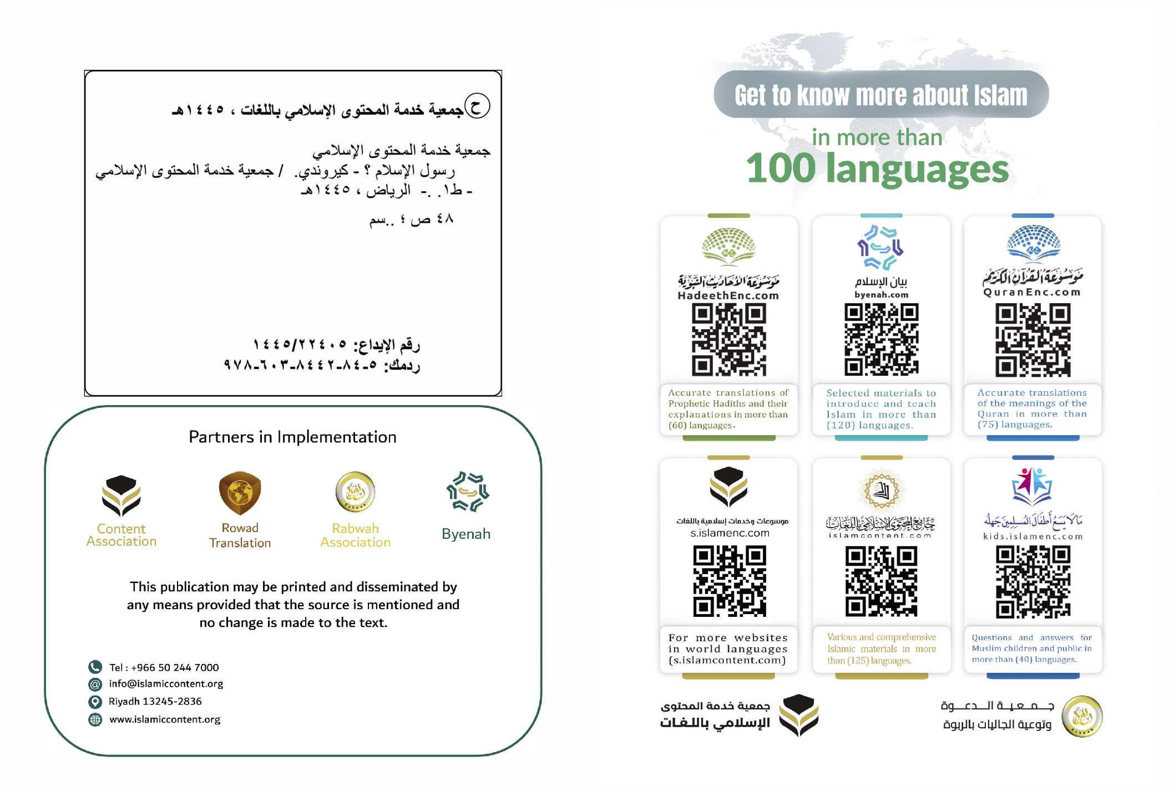

Nitwararitse gukurikiranya amajambo abiri: Intumwa Muhamadi (Ijambo Intumwa n'ijambo Muhamadi), kugira gusa nubahirize inyubako y'ivyanditswe.
Yumvikanweko na Al-Bukhaariy na Muslimu. Yakiriwe na Aisha (Imana Allah Imwishimire). "Iyi nyigisho iri mu gitabu "Swahiihu Al-Bukhaariy 1/7"; no muri "Swahiihu Muslim 1/139".
Yashikirijwe na Muslimu.
Yashikirijwe na Al-Bukhaariy.
Akarorero, ni nk'ijambo ry'Imana Allah aho Ivuga Iti: ﴾Emwe bantu! Mwaraciriwe agace, nimutege amatwi rero mukumvirize mwongere mukazirikane. Mu vy’ukuri, ibigirwamana musenga mu gishingo c’Imana Allah, ntibizopfa bishoboye kurema n’isazi imwe gusa n’aho vyogira urunani, nkeswe rero kurema igisumba isazi! No mu gihe isazi yogira ico yihagiye mu kununuza kimwe mu vyatanzweko ikimazi ku bigirwamana, nya bigirwamana ntivyoshobora kuyaka ico yihagiye. Ibigirwamana rero, nta na kimwe bishoboye kuko ata bubasha bwo kurema bifise, eka ntibinafise n’ububasha bwo guhabuza ivyo isazi yihagiye, bitayeko n’isazi ubwayo nyene nta co ishoboye ﴿(Al-Hajji: 73).

